Group 12 – Game Research Document

Turn-Based Mechanic: In this brief we have been given very specific mechanics that we need to apply in our game; the most important one is the turn-based system, this can be handled in two ways. First choice is where the players take turns before each action, take chess as example; players take turns before moving each chess piece. The second way is changing when one player dies; this means that there can be two roles, and the players swap roles after one player has died.

Single Input: Our game can only contain single input, this means that the player can only be able to tap on the screen of the device and this will cause a certain action to happen; for example, when the player taps on the screen, the in-game character jumps in the air.

Cooperative/Competitive: The game can be a cooperative game, this is where the players must work with each other to beat the game; for example, in Tower of Babel, the players must work with each other to construct the highest tower possible. A competitive game, would be where player would have two separate towers, and whoever built the tallest one, wins as they would be directly competing.

Symmetrical: As mentioned on the brief, the game has to also be symmetrical; now this is impossible with a turn-based gameplay as one player will always have advantage (starting player); thus I assume the level design needs to be kept symmetrical, giving both players the same chance.

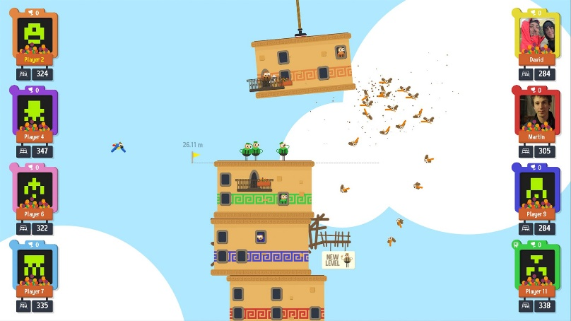

*Tower of Babel*

Cooperative (coop) games are the type of games where the players must work together to achieve the goal of the game, while there can be competitive aspect to the game it is most of the time about working together rather than trying to beat each other.

The first example comes from a game called Tower of Babel, in this game the player must build a tower together, and essentially the height is the score; the higher the tower, the bigger the score. In the game multiple players need to work together to keep the stack as straight as they can, because once wind starts affecting the tower it can fall apart, and the game will be over; when a block of the tower is dropped, and it falls off the side of the screen, the game ends too.

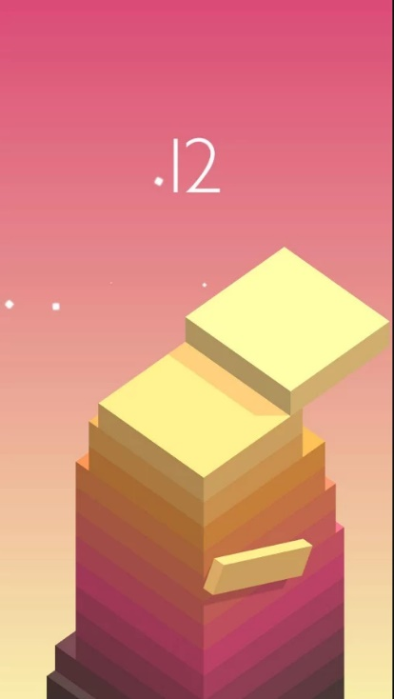

*Stack*

Another example of a similar game is Stack by Ketchapp, but unlike the previous game, Stack is single player only. The main objective of the game is to build the highest stack of cubes as its possible; the twist is that whenever a piece of the cube sticks outside of the stack, the part will be cut off and this will make the stack smaller and harder to get the next piece perfectly.

In this type of game, the game gets more difficult as it progresses; in most cases when player misses the perfect landing on one of the pieces it will start being more difficult to get another perfect stack. Another mechanic that can be used to increase the difficulty is to increase the speed at which the stack moves, so that is more difficult for the player to get perfect stack; or move the camera vertically all the time, so players must race with the camera. This can easily be adapted into a turn based mobile game, just like Tower of Babel.

Stack also uses a very minimalistic yet vibrant graphics, this can easily be applied for our game, and most likely be the best choice.

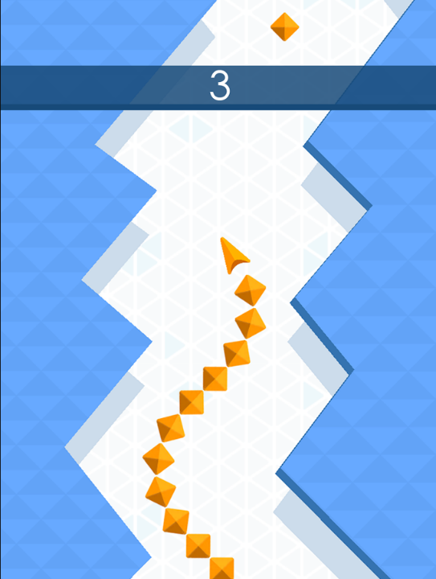*Arrow*

In this game the player controls the arrow, whenever the player taps the arrow changes direction. In this game the players could be taking turn in whoever gets the higher score; one player will go after the other. A twist can be put, where the level is changed whenever the player fails, so that the other player waiting for their turn can’t learn the layout of the level (creating procedural generation is not something we want to even think about).

A spin on the game that can be added is a Tetris mechanic, where one player is currently playing through the level and the other player places obstacles for the first player to avoid; later when the player dies they swap roles. This way we keep the turn-based mechanic (?) and we can adapt a monochromatic esthetics in the game.

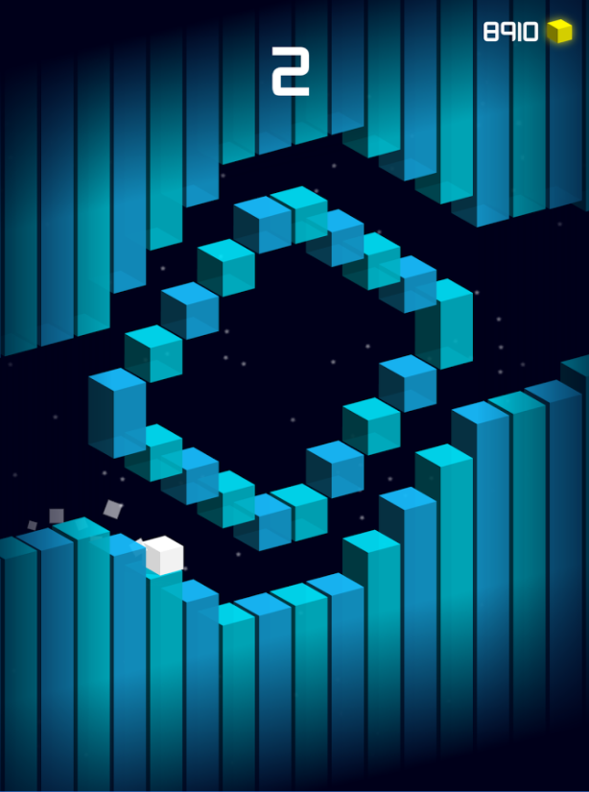

*Gravity Switch*

In Gravity Switch the player uses one tap mechanic to switch the gravity in the level, allowing them to walk on the ceiling of the level. This is a very simple idea for a game, and for our brief it could be modified to where one player controls the gravity, and the other player is controlling gravity; once the player dies, they swap roles.

The main goal of the game would be to get the best score, while trying to work together to achieve that. The controls could be split into half of the screen, one half controls the jumping while the other half controls the gravity.